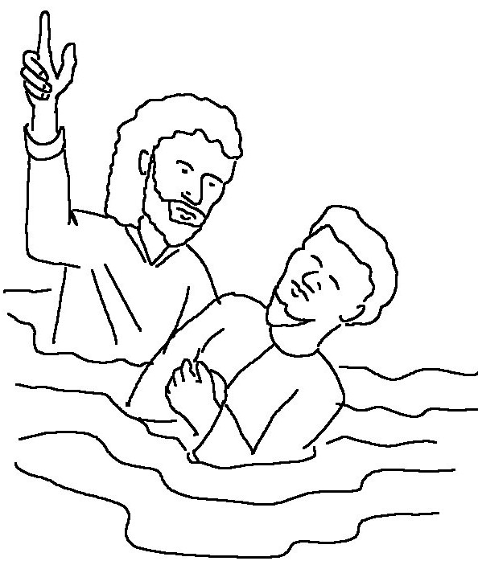
But you will receive _ _ _ _ _ when the Holy Spirit comes upon you. And you will be my witnesses, _ _ _ _ _ _ _ people about me everywhere…
Acts 1:8 _{NLT}

